STD.ISO 3209-ENGL 1998 4851903 0776033 T94

INTERNATIONAL

STANDARD

OSI

3209

Second edition

1998-11-15

Aerospace-Nuts, anchor, self-locking,

floating, two lug, with counterbore, with

MJ threads,classifications: 1 100 MPa (at

ambient temperature)/235 °C, 1 100 MPa (at

ambient temperature)/315 °C and 1 100 MPa

(at ambient temperature)/425C-

Dimensions

Aéronautique et espace-Écrous à river, à freinage interne, flottants,

double patte, avec chambrage, à filetage MJ, classifications: 1 100 MPa (à

température ambiante)/235 C, 1 100 MPa (à température

ambiante)/315 °C et 1 100 MPa (à température ambiante)/425℃-

Dimensions

This material is reproduced from ISO documents under International Organization for Standardization(ISO)Copyright License Number IHS/ICC/1996. Not for resale.No part of these ISO documents may be reproduced in any form,electronic retrieval system or otherwise, except as allowed in the copyright law of the country of use, or with the prior written consent of ISO (Case postale 56,1211 Geneva 20,Switzerland,Fax+41 22 734 10 79),IHS or the ISO Licensor's members.



Reference number

ISO 3209:1998(E)

COPYRIGHT 2000 International Organization For Standardization

Information Handling Services, 2000

STD.ISO 3209-ENGL 1998

4851903 0776034 920

ISO 3209:1998(E)

Foreword

ISO (the International Organization for Standardization) is a worldwide federation of national standards bodies (ISO member bodies). The work of preparing International Standards is normally carried out through ISO technical committees. Each member body interested in a subject for which a technical committee has been established has the right to be represented on that committee.International organizations, governmental and non-governmental, in liaison with ISO,also take part in the work. ISO collaborates closely with the International Electrotechnical Commission (IEC) on all matters of electrotechnical standardization.

International Standards are drafted in accordance with the rules given in the ISO/IEC Directives,Part 3.

Draft International Standards adopted by the technical committees are circulated to the member bodies for voting. Publication as an International Standard requires approval by at least 75 % of the member bodies casting a vote.

International Standard ISO 3209 was prepared by Technical Committee ISO/TC 20, Aircraft and space vehicles,Subcommittee SC 4,Aerospace fastener systems.

This second edition cancels and replaces the first edition (ISO 3209:1989), which has been technically revised.

ISO 1998

All rights reserved.Unless otherwise specified, no part of this publication may be reproduced or utilized in any form or by any means, electronic or mechanical,including photocopying and microfilm,without permission in writing from the publisher.

Intemational Organization for Standardization

Case postale 56·CH-1211 Genève 20·Switzerland

Intemet iso@iso.ch

Printed in Switzerland

ii

COPYRIGHT 2000 International Organization For Standardization

Information Handling Services,2000

STD.ISO 3209-ENGL 1998 4851903 0776035 867

ISO

ISO 3809:1998(E)

Introduction

The dimensions specified in this International Standard have been determined to allow production of a part which will satisfy the requirements of the procurement specification ISO 5858.

COPYRIGHT 2000 International Organization For Standardization

Information Handling Services,2000

STD.ISO 3209-ENGL 1998 4851903 0776036 7T3

INTERNATIONAL STANDARD ISO

ISO 3209:1998(E)

Aerospace - Nuts, anchor, self-locking, floating, two lug, with

counterbore, with MJ threads, classifications: 1 100 MPa (at

ambient temperature)/235 °C, 1 100 MPa (at ambient

temperature)/315 °C and 1 100 MPa (at ambient

temperature)/425 ℃-Dimensions

1 Scope

This International Standard specifies the dimensions of self-locking, floating, two lug anchor nuts,with counterbore, with MJ threads,of classifications:1 100 MPa 1/235 °C 2), 1 100 MPa 1/315 °C 2) and 1 100 MPa 1)/425 °C 2).

This International Standard is only applicable for the compilation of aerospace product standards.

2 Normative references

The following normative documents contain provisions which,through reference in this text, constitute provisions of this International Standard. For dated references,subsequent amendments to, or revisions of, any of these publications do not apply. However, parties to agreements based on this International Standard are encouraged to investigate the possibility of applying the most recent editions of the normative documents indicated below.For undated references,the latest edition of the normative document referred to applies. Members of ISO and IEC maintain registers of currently valid International Standards.

ISO 5855-2:1988,Aerospace-MJ threads-Part 2:Limit dimensions for bolts and nuts.

ISO 5858:1991,Aerospace-Self-locking nuts with maximum operating temperature less than or equal to 425℃-Procurement specification.

ISO 8788:1987,Aerospace-Fasteners-Tolerances of form and position for nuts.

3 Configuration and dimensions

See Figure 1 and Table 1. Dimensions and tolerances are expressed in millimetres. They apply after any surface coating(s) but before the application of any lubricant.

The metallic cap (optional) shall remain joined to the nut at the maximum operating temperature (type of attachment at the user's discretion). See ISO 5858 for the test conditions.

1) Corresponds to the minimum tensile stress which the nut is able to withstand at ambient temperature without breaking or cracking when tested with a bolt of a higher strength class.

2) Maximum temperature that the nut is able to withstand, without permanent alteration to its original characteristics, after ambient temperature has been restored.The maximum temperature is conditioned by the surface treatment.

1

COPYRIGHT 2000 International Organization For Standardization

Information Handling Services,2000

STD.ISO 3209-ENGL 1998

ISO 3209:1998(E)

4851903 0776037 63T

ISO

6.3/(33/)

Remove sharp edges 0.1 to 0.4

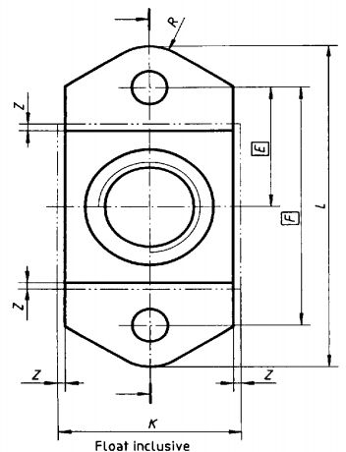

X(2:1)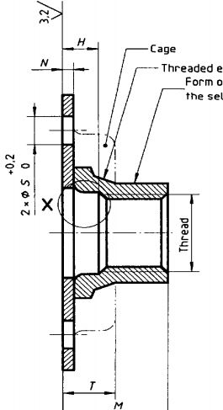

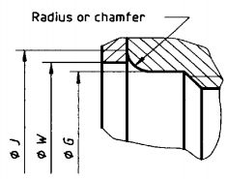

Threaded element

Form out-of-round in this area to achieve

the self-locking torque requirementb

Configuration with cap

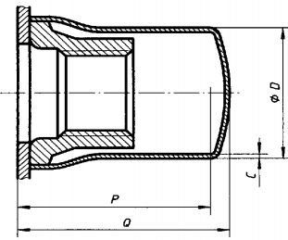

Alternatives:countersunk rivet holes(when specified by purchaser)may be dimpled or

cut countersunk lat manufacturer's option)

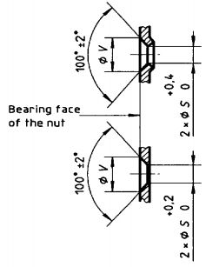

Tolerances of form and position shall conform to those specified in ISO 8788. Details of form not stated are at the manufacturer's discretion.

a These values, in micrometres, apply before any surface coating(s) is (are) applied. The values do not apply to threads, punched holes or shear edges the surface texture of which will be as achieved by the usual manufacturing methods.

b Tooling marks permissible in this area

Figure 1

2

COPYRIGHT 2000 International Organization For Standardization

Information Handling Services,2000

STD.ISO 3209-ENGL 1998 4851903 0776038 576

ISO

ISO 3209:1998(E)

Table 1

|  |  |  |  |  |  |  |  |  |  |  |  |  |  |  |  |  |  |  |  |  |
| --- | --- | --- | --- | --- | --- | --- | --- | --- | --- | --- | --- | --- | --- | --- | --- | --- | --- | --- | --- | --- |
| Diameter  code | Threada | C  max. | D  max. | E | F | G  min. | H  min. | Jb  max. | K  max. | L  max. | M  max. | N  max. | od  max. | Q  max. | R  - | S | T  max. | V  ±0.25 | W  min. | Radial  float  Z  min. |
| 030 | MJ3x0,5-4H6H | - | - | 8.5 | 17 | - | - | 4,6 | 11 | 23,2 | 4 | 0.9 | - | - | 3 | 2,5 | 4.5 | 4.8 | 4,5  5.5 | 0.5 |
| 040 | MJ4x0.7-4H6H | 0.4 | 6,6 | 4.4 | 2.2 | 6.2 | 5.8 | 11 | 13 |
| 050 | MJ5x0.8-4H6H | 8.1 | 9.5 | 19 | 5,5 | 2,4 | 7,3 | 12 | 25,2 | 6,9 | 11,4 | 13,4 | 6,5 | 0.7 |
| 060 | MJ6x1-4H5H | 9,2 | 11 | 22 | 6.5  8,5 | 2,7 | 8,7 | 13.5 | 29,2 | 8,1 | 12,7 | 14.7 | 3.5 | 4.6 | 7.5 |
| 080 | MJ8x1-4H5H | 0,5 | 12,8 | 10,9 | 16 | 9.9 | 1.1 | 15 | 18 | 3 | 5,5 | 5.7 | 9.5 | 0.75 |
| 100 | MJ10x1,25-4H5H | 15 | 13 | 26 | 10.5 | 3 | 12,9 | 18 | 35,2 | 12 | 20.2 | 22 | 4,5 | 3.5 | 6 | 6,6 | 11.5 |
| B In accordance with ISO 5855-2.In the self-locking zone,the tolerances apply before forming out-of-round.  b Measured at sharp comers (chamfered)or point of tangency (radiused)  0 Maximum protrusion of the bolt | | | | | | | | | | | | | | | | | | | | |

3

COPYRIGHT 2000 International Organization For Standardization

Information Handling Services,2000

ISO 3209:1998(E)

STD.ISO 3209-ENGL 1998 4851903 0776039 402

ISO

ICS 49.030.30

Descriptors: aircraft industry, fasteners.MJ threads, nuts (fasteners), anchor nuts, self-locking nuts,two lug nuts, floating nuts. counterbore nuts,classification,form specifications, dimensions.

Price based on 3 pages

COPYRIGHT 2000 International Organization For Standardization

Information Handling Services,2000